Roadkill Hotspots & Policy Advocacy: An AI-Driven Approach
Abstract
Roadkill incidents are a significant threat to wildlife, with thousands of animals succumbing to vehicle collisions annually. This research introduces an AI and IoT-based solution for detecting high-risk animal crossings, classifying their status, and alerting drivers in real time. The proposed system integrates YOLOv5xu for object detection, DenseNet and EfficientNet-based CNN models for dead/alive classification, and IoT sensors (ESP32, ultrasonic, DHT) for immediate response. Additionally, heatmap analysis and predictive analytics provide insights into roadkill hotspots, facilitating informed policy decisions. This multi-layered approach aims to enhance road safety while minimizing ecological disruptions.
1. Introduction
1.1 Background & Theme
The increasing expansion of road networks has led to a rise in roadkill incidents, significantly impacting biodiversity. Reports indicate that in some regions, over 300+ roadkill cases occur within a 10-month period. These incidents not only endanger wildlife but also pose safety risks to drivers. Existing mitigation measures lack real-time response capabilities, necessitating an advanced AI-driven solution.
1.2 Objectives
The primary objectives of this research are:
- Real-time animal detection using YOLOv5xu.
- Classification of detected animals as alive or dead using CNN models.
- Risk assessment via Optical Flow-based movement tracking.
- IoT-based driver alerts using smart signage.
- Roadkill hotspot analysis using heatmaps to aid policy advocacy.
1.3 Multilayered Approach
The proposed system follows a three-dimensional AI-based framework:
- D1: Computer Vision (YOLOv5xu) – Detects animals, movement speed, and classifies risk.
- D2: ML Model (DenseNet & EfficientNet) – Determines if detected animals are alive or dead.
- D3: IoT-Based System (ESP32, Ultrasonic Sensors) – Provides real-time driver alerts.

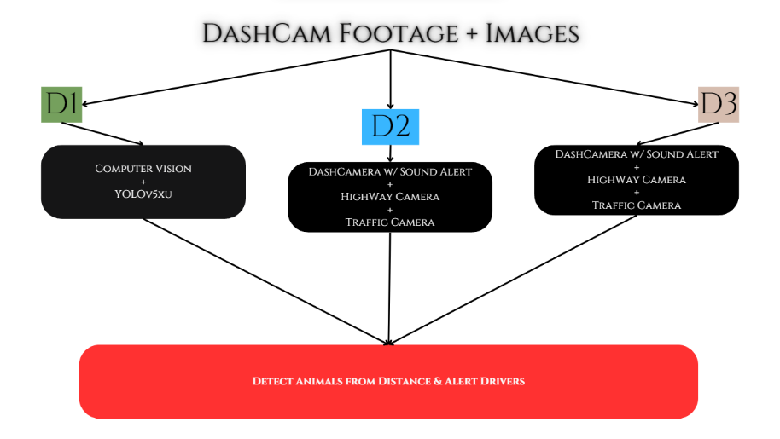

2. Technology Stack
2.1 AI-Based Animal Detection (YOLOv5xu)
- Trained on highway surveillance footage for accurate species detection.
- Integrates Farneback Optical Flow to estimate movement speed and risk levels.
deployed through multiple Gradio interfaces for scalability.
2.2 CNN-Based Dead/Alive Classification
- Utilizes DenseNet-121 and EfficientNet-B3, achieving 94-98% accuracy.
- Implements L2 regularization and dropout techniques to mitigate overfitting.
deployed via a Flask-based API for real-time inference.
2.3 IoT Integration for Real-Time Alerts
- ESP32 + Ultrasonic Sensors detect approaching obstacles.
- Smart signage with LED and buzzer system warns drivers of detected animals.
- DHT Sensor collects environmental data for additional analysis.

3. System Design & Implementation
3.1 AI-Based Roadkill Detection (D1 & D2)
- Capture: Video feeds from dashcams and highway surveillance are processed.
- Detection: YOLOv5xu identifies animals and classifies sudden movements as high-risk.
- Classification: A CNN model assesses if the animal is alive or dead.
- Alert System: If alive, IoT-based alerts notify drivers; if dead, municipal corporations are informed for disposal.
3.2 IoT-Based Real-Time Alerts (D3)
- ESP32 + Ultrasonic Sensors detect objects near highways.
- Smart signage with LED indicators and buzzers alerts drivers.
- Data is logged into a Firebase database for further analysis.
3.3 Data Collection for Heatmap & Policy Advocacy
- Roadkill event logs are stored in Firebase.
- Heatmap analysis identifies high-risk zones.
- Authorities receive real-time dashboard insights for mitigation measures.

4. Evaluation & Results
4.1 AI Model Performance
- YOLOv5xu achieved 95% accuracy in identifying high-risk animals.
- DenseNet & EfficientNet attained 94-98% accuracy in classifying dead /alive status.
4.2 Real-Time Testing & Deployment
- IoT alerts triggered within 500ms, ensuring rapid response.
- Heatmap analysis validated repeated hotspots, reinforcing the need for policy intervention.

5. Policy Advocacy & Future Scope
5.1 Policy Recommendations
- Mandatory AI-powered dashcams on wildlife-prone roads.
- Deployment of smart signage systems for driver warnings.
- Collaboration with governments & automakers to integrate AI-based roadkill prevention mechanisms.
5.2 Future Enhancements
- Edge AI & TinyML integration for real-time low-power inference.
- 5G connectivity for faster cloud-based data transmission.
- Autonomous vehicle compatibility to enable automatic braking upon animal detection.

- Conclusion
This study successfully demonstrates an AI-IoT-based approach to minimizing roadkill incidents. By integrating computer vision, machine learning, and IoT-based alerts, the system ensures real-time risk mitigation. Predictive analytics further support policy advocacy for safer roads. With continuous enhancements, this system can be globally deployed to protect both wildlife and human lives.

- References
- Research on Roadkill Incidents & Biodiversity Impact.
- OpenCV Documentation for Optical Flow Tracking.
- YOLOv5 Official Repository & Object Detection Research.
- EfficientNet & DenseNet Studies on Image Classification.
- IoT-Based Traffic Monitoring & Smart Signage Research.

Lokesh Patra | Indigibilli Harshit

